**

**Document Title:** **Connect Metric dashboard**

Runbook

**Version:** 0.1

**Prepared by: Graeme Flack**

Cloud Solution Consultant

**14 April 2019**

**Classification:**

Commercial in Confidence

**Contents**

1 Introduction 3

1.1 Purpose 3

1.2 Intended audience 3

1.3 Prerequisites 3

2 Installation 4

3 Configuration 4

3.1 Directory structure 4

3.1.1 Config 4

3.1.2 Scripts 4

3.1.3 Src 4

3.2 Configuration file 4

3.3 AWS Credentials 5

4 Script Execution 5

5 Scheduling 6

# Introduction

## Purpose

This document is a guide to configuring the Amazon Connect metrics scripts to integrate with the PowerBI dashboard solution. The scripts use configuration to establish the Amazon Connect instance to connect to and the queues to query.

**Note**

The configuration will need to be updated as new clients and queues are added. This is required due to current limitations in the Amazon Connect API.

Two scripts are provided to support the solution:

* connectmetrics.py - A python script that invokes the `get_metric_data` and `get_current_metric_data` APIs and flattens

the results in JSON format.

* connect-metrics-cli.ps1 - A powershell wrapper that invokes the `connectmetrics.py` script and sends the results to

PowerBI.

## Intended audience

This is a technical document intended primarily for the MI team to configure the scripts on the PowerBI reporting server.

A good level of technical infrastructure knowledge and familiarity with AWS profiles and IAM credentials have been assumed.

## Prerequisites

The following prerequisites are required to run the scripts:

* Python 3.7 - <https://www.python.org/downloads/>
* AWS CLI - <https://aws.amazon.com/cli/>

# Installation

The script and configuration files will be provided in the connect-dashboard-metrics.zip file. Extract the zip file to a suitable directory on the reporting server.

# Configuration

## Directory structure

Once unzipped, the following directory structure should be available:

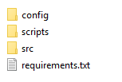

### Config

Contains the configuration files for each client and environment. The configuration is stored in JSON format and will be discussed later.

### Scripts

Contains the powershell script to initiate the metric retrieval and push the results to PowerBI

### Src

Contains the python source script that queries the Amazon Connect Metrics API using the AWS SDK.

#### Requirements

This file contains the dependencies required to execute the python script.

## Configuration file

A configuration file will exist for each client and each environment, e.g. tradeuk-dev.json, tradeuk-prod.json etc. The format of the file is as follows:

{

"clientName": "<name of the client to identify the metrics in PowerBI, e.g. TradeUK>",

"accountId": "<the id of the account to access>",

“environment”: “<the environment to connect to>”,

"instanceId": "<connect instance GUID>",

"queues": {

"<Queue Id GUID>": "<Queue Name>",

"<Queue Id GUID>": "<Queue Name>"

}

}

An example configuration is show below:

{

"clientName": "TradeUK",

"accountId": "111111111111",

“environment”: “DEV”,

"instanceId": "0d525d33-c2af-4b86-9d67-393db396e896",

"queues": {

"e42fa1d8-620e-4bf8-bd9a-eafc60b9c0ef": "BasicQueue"

}

}

The instance id, account id and queue id can be found in the Amazon Connect dashboard in the Edit queue screen if you click on Show additional queue information.

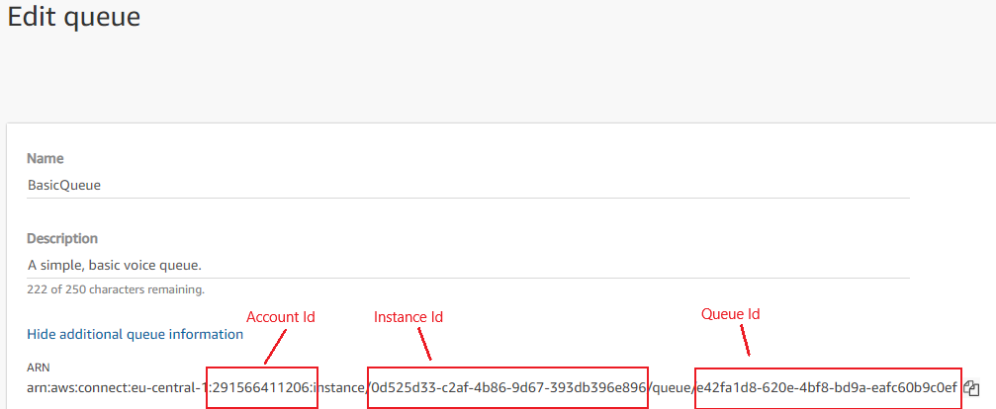

## AWS Credentials

Credentials will be provided for the common account that have access to assume a role in a each of the client accounts. Once provided, the **aws_access_key_id** and **aws_secret_access_key** need to be added to the **<user_home>/.aws/credentials** file under a suitable profile name. Credentials will be provided for both the Prod and NonProd accounts.

# Script Execution

To run the dashboard script, run the following command:

.\scripts\connect-metrics-cli.ps1 -Client <client> -Environment <environment> -ProfileName <profile name> -PowerBIUrl <PowerBIUrl>

e.g.

.\scripts\connect-metrics-cli.ps1 -Client tradeuk -Environment dev -ProfileName capita-tradeuk-dev -PowerBIUrl http://localhost:8080

# Scheduling

The script is designed to query the Amazon Connect Metrics once. This was to decouple the execution from the scheduling. Windows scheduled tasks should be configured to run the script on a timed basis for each of the clients/environments as necessary.